**Zhumagali Kanat IT2-2003**

**Lab3. Handling exceptions**

1. Add at least three exception handling sections that trap all three different types of exceptions (pre-defined, non-predefined, user-defined).
2. Try incorporating exception handling into the anonymous blocks you created in lab 2.

1.predefined

declare

type fin_info is record(

m_id movie.movie_id%type,

m_name movie.film_name%type,

f_b finance.budget%type,

f_i finance.income%type

);

f_rec fin_info;

begin

select m.movie_id, m.film_name, f.budget, f.income into f_rec from movie_fin mf join movie m on mf.movie_id = m.movie_id join finance f on mf.fin_id = f.fin_id;

exception

when too_many_rows then dbms_output.put_line('Too many rows');

when no_data_found then dbms_output.put_line('No data found');

when others then dbms_output.put_line('Some error ocures');

end;

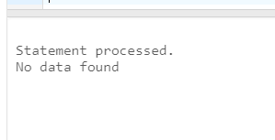

2.non-predifined

declare

inv_cursor exception;

pragma exception_init(inv_cursor, -6511);

cursor dir_cursor is select director_id, first_name, last_name, date_of_birth from directors where extract(year from date_of_birth) > 1960;

begin

open dir_cursor;

for dir_rec in dir_cursor loop

dbms_output.put_line('ID: '||dir_rec.director_id || ' ' ||' First name: ' || dir_rec.first_name || ' Last name: ' || dir_rec.last_name || ' Date of birth: ' || dir_rec.date_of_birth );

end loop;

close dir_cursor;

exception

when inv_cursor then dbms_output.put_line(SQLERRM);

end;

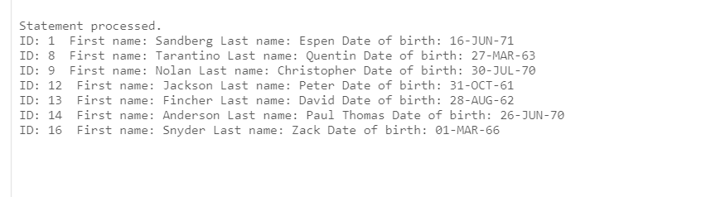

3.user-defined

declare

c_name country.country_name%type;

data_col exception;

cursor movie_cursor is select m.film_name, c.country_name from movie_country mc join movie m on mc.movie_id = m.movie_id join country c on mc.country_id = c.country_id;

begin

c_name := 'Japan';

for country_rec in movie_cursor loop

if (country_rec.country_name = c_name) then raise data_col;

else dbms_output.put_line(country_rec.film_name || ' ' || country_rec.country_name);

end if;

end loop;

exception

when data_col then dbms_output.put_line('tea time');

end;

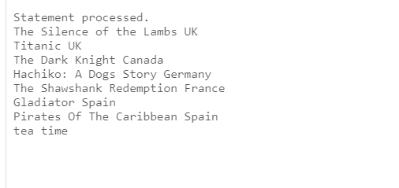

sELECT round(dbms_random.value(1, 20)) FROM dual

declare

m_id movie.movie_id%TYPE;

c_id country.country_id%TYPE;

begin

FOR i IN 1..20 LOOP

m_id := i;

c_id := ROUND(DBMS_RANDOM.VALUE(1, 20));

insert into movie_country (movie_id, country_id) values (m_id, c_id);

commit;

end loop;

end;

lab2 with errors:

declare

yor movie.year_of_release%type := 2100;

cursor sal_cursor is select movie_id, film_name, duration, year_of_release from movie where year_of_release > yor order by year_of_release asc;

begin

for sal_record in sal_cursor loop

dbms_output.put_line('Movie id : ' || sal_record.movie_id || ' Film name : ' || sal_record.film_name || ' Duration: ' || sal_record.duration || ' Year of release: ' || sal_record.year_of_release );

end loop;

exception

when no_data_found then dbms_output.put_line('No data found');

when too_many_rows then dbms_output.put_line('Too many rows');

when others then dbms_output.put_line('Some error ocures');

end;

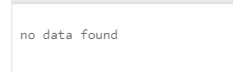

declare

invalid_id exception;

type movie_info is record(

movie_id movie.movie_id%type,

film_name movie.film_name%type,

duration movie.duration%type,

rating_imbdb movie.rating_imbdb%type

);

my_id number;

m_info movie_info;

cursor m_info_cursor is select movie_id, film_name, duration,rating_imbdb from movie where movie_id = my_id;

begin

my_id := 22;

if my_id > 20 then raise invalid_id;

else open m_info_cursor;

fetch m_info_cursor into m_info;

close m_info_cursor;

dbms_output.put_line(m_info.movie_id || ' ' || m_info.film_name || ' ' || m_info.duration);

end if;

exception

when invalid_id then dbms_output.put_line('invalid id');

when others then dbms_output.put_line(SQLERRM);

end;

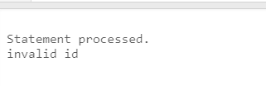

declare

budget_invalid exception;

pragma exception_init(budget_invalid, -6502);

type movie_fin_info is record(

movie_id movie.movie_id%type,

film_name movie.film_name%type,

budget finance.budget%type,

income finance.income%type

);

m_info movie_fin_info;

my_b number;

cursor fin_cursor is select m.movie_id, m.film_name, f.budget, f.income from movie_fin mf join movie m on mf.movie_id = m.movie_id join finance f on mf.fin_id = f.fin_id;

begin

my_b := 100000;

for fin_record in fin_cursor loop

m_info := fin_record;

if my_b != to_number(m_info.budget) then

raise budget_invalid;

end if;

if(to_number(m_info.budget) > my_b) then dbms_output.put_line('||Film name: ' || m_info.film_name || ' has budget: ' || m_info.budget || ' and his income: ' || m_info.income || '||');

else dbms_output.put_line(m_info.film_name || ' has budget whis is less ' || my_b);

end if;

end loop;

exception

when budget_invalid then dbms_output.put_line('Invalid budget ');

when others then dbms_output.put_line(SQLERRM);

end;

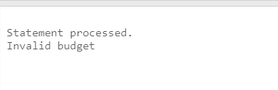

declare

budget_invalid exception;

budget_max_inv exception;

pragma exception_init(budget_invalid, -6502);

type movie_fin_info is record(

movie_id movie.movie_id%type,

film_name movie.film_name%type,

budget finance.budget%type,

income finance.income%type

);

m_info movie_fin_info;

my_b number;

cursor fin_cursor is select m.movie_id, m.film_name, f.budget, f.income from movie_fin mf join movie m on mf.movie_id = m.movie_id join finance f on mf.fin_id = f.fin_id;

max_b finance.budget%type;

begin

select max(to_number(budget)) into max_b from movie_fin mf join movie m on mf.movie_id = m.movie_id join finance f on mf.fin_id = f.fin_id;

my_b := 5000000;

if(my_b > max_b) then raise budget_max_inv;

end if;

for fin_record in fin_cursor loop

m_info := fin_record;

if(to_number(m_info.budget) > my_b) then dbms_output.put_line('||Film name: ' || m_info.film_name || ' has budget: ' || m_info.budget || ' and his income: ' || m_info.income || '||');

else dbms_output.put_line(m_info.film_name || ' has budget whis is less ' || my_b);

end if;

end loop;

exception

when budget_max_inv then dbms_output.put_line ('Max budget in data is '|| my_b);

when budget_invalid then dbms_output.put_line('Invalid budget ');

when others then dbms_output.put_line(SQLERRM);

end;

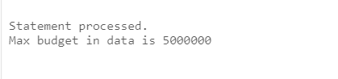

Questions:

1. What is an exception?
2. What types of exceptions exist in PL/SQL?
3. How are exceptions handled?
4. Describe the structure of the exception handling section.
5. What are predefined Oracle server errors and how are they handled?
6. What are non-predefined Oracle server errors and how are they handled?
7. What are user-defined exceptions and how are they handled?